Clinical Services System (CSS)
The CSS represents a web-based application developed and provided by FFT LLC to support and guide therapists in adhering to the FFT model. The system includes progress notes, assessment instruments, and a reports section that identifies family changes and outcomes. Utilization of the CSS is required for all therapists and supervisors in order to remain a certified FFT team.

Here is a screenshot of the Therapist dashboard of the CSS:
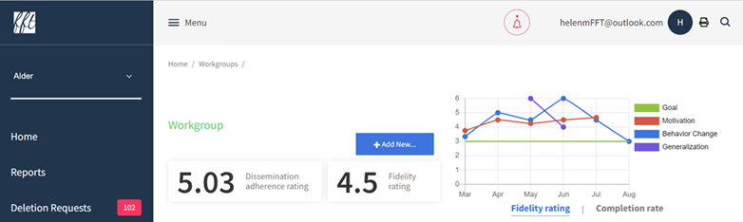

The CSS has 3 areas of data entry:
- Basic Client/Family Information
  - Completed one time at beginning of treatment
  - Average time to complete this section: 5 minutes
- Assessments
  - Majority completed pre and post treatment
  - Average time to complete this section: 5 minutes per assessment
- FFT Contact Notes
  - Quick documentation of outreach or brief interactions
  - Average time to complete: less than 5 minutes
- FFT Session Notes
- Reflective section where the therapist documents each session and plans for the next. Basic content automatically carries over to simplify data entry
- Average time to complete: 10-20 minutes depending on phase of treatment and therapist skill and experience

FFT LLC’s API for the CSS
The CSS has an API (Application Programming Interface) available to streamline and simplify data entry between electronic record systems for FFT LLC sites. This optional tool allows a provider to electronically download data from the CSS to another database including EHR systems, reducing the burden on staff for the double data entry that is typically required with all EBP usage. This download is HIPPA compliant as the data traveling between the systems is fully encrypted.

